Computer Networks
Lab 12

- Is your browser running HTTP version 1.0 or 1.1? What version of HTTP is the server running?
1.1

- What languages (if any) does your browser indicate that it can accept to the server?
Text/Plain

- What is the IP address of your computer? Of the gaia.cs.umass.edu server?
10.5.116.216

- What is the status code returned from the server to your browser?
200

- When was the HTML file that you are retrieving last modified at the server?
Last-Modified: Thu, 03 Apr 2025 16:14:25 GMT\r\n

- How many bytes of content are being returned to your browser?

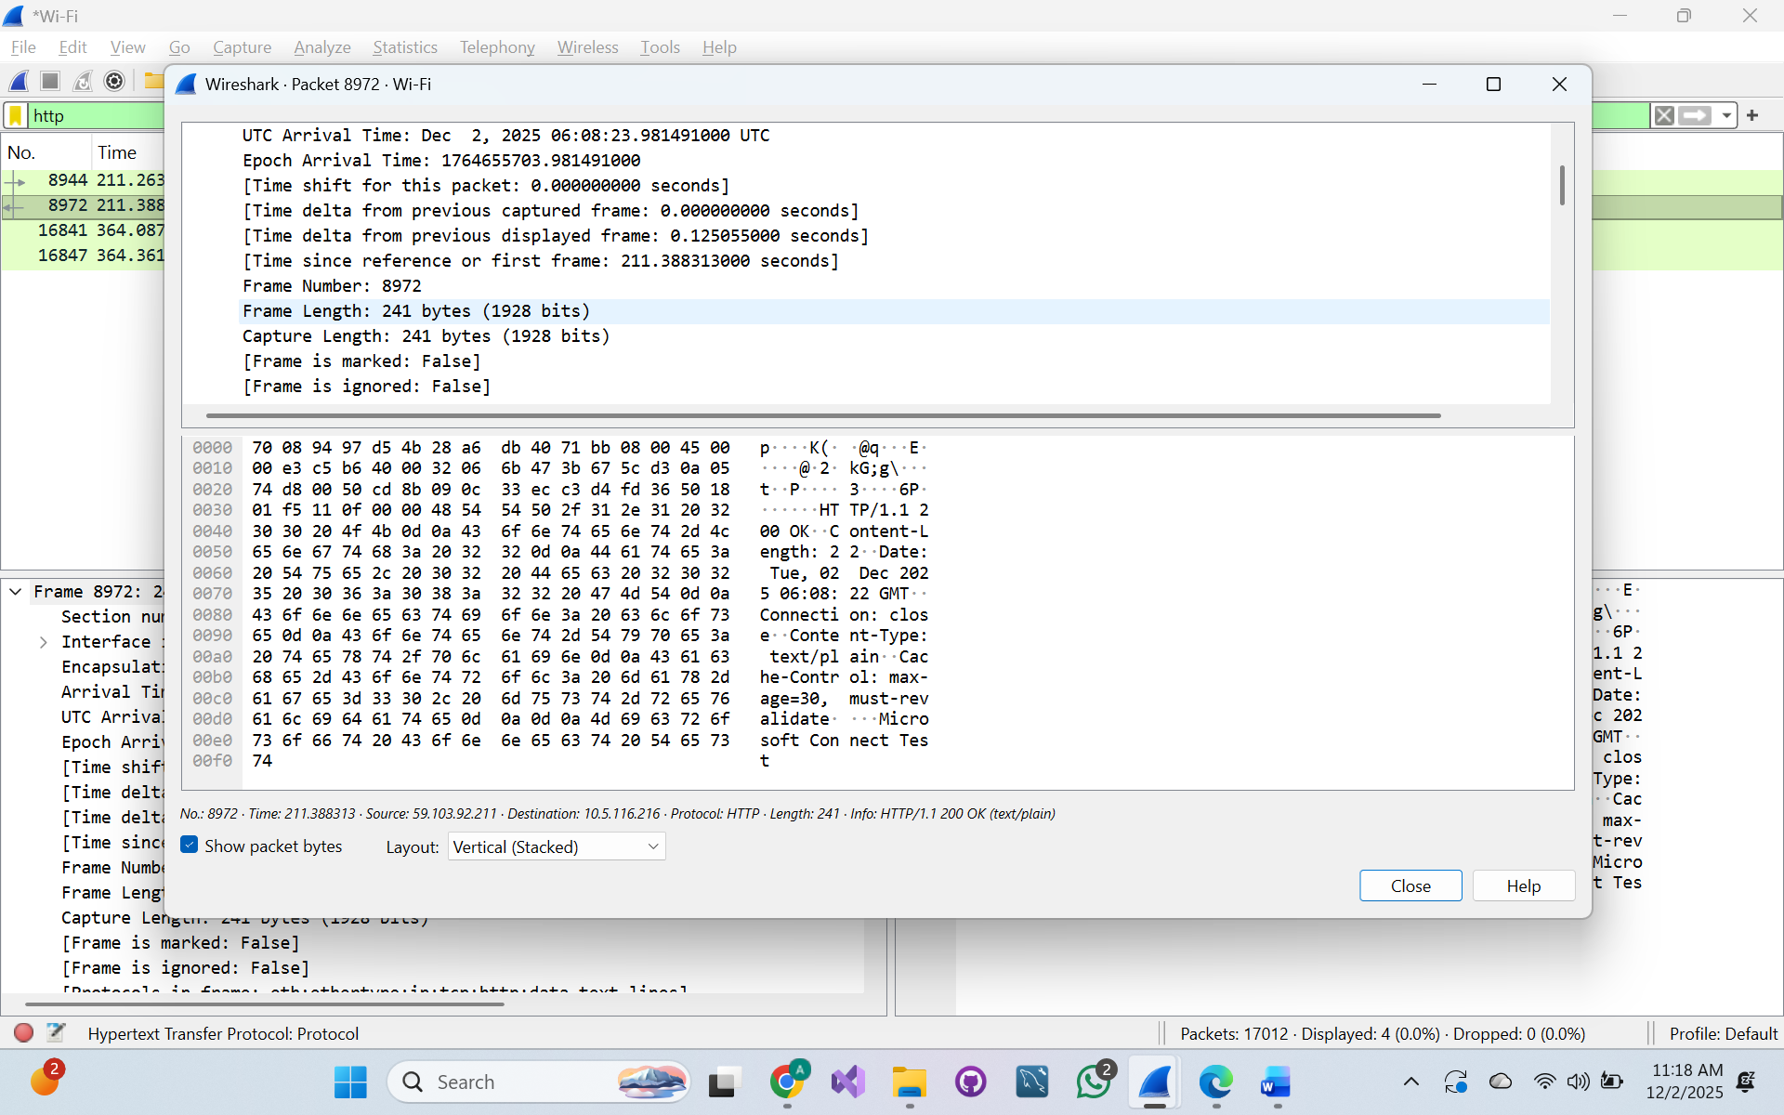
241 bytes of data is captured

- By inspecting the raw data in the packet content window, do you see any headers within the data
Acknowledgement Number

